

**LAB 9**

**CODE:**

Create database online_shop;

use online_shop;

CREATE TABLE Customers (

Customer_ID INT PRIMARY KEY,

Customer_Name VARCHAR(30),

Contact_Number VARCHAR(15),

Address VARCHAR(100)

);

CREATE TABLE Categories (

Category_ID INT PRIMARY KEY,

Category_Name VARCHAR(50)

);

CREATE TABLE Products (

Product_ID INT PRIMARY KEY,

Product_Name VARCHAR(50),

Supplier_ID INT,

Category_ID INT,

Product_Price DECIMAL(10, 2),

Quantity INT,

FOREIGN KEY (Category_ID) REFERENCES Categories(Category_ID),

FOREIGN KEY (Supplier_ID) REFERENCES Suppliers(Supplier_ID)

);

CREATE TABLE Suppliers (

Supplier_ID INT PRIMARY KEY,

Supplier_Name VARCHAR(25),

Contact_Number VARCHAR(15),

Address VARCHAR(100)

);

CREATE TABLE Orders (

Order_ID INT PRIMARY KEY,

Customer_ID INT,

Order_Date DATE,

Status VARCHAR(50),

FOREIGN KEY (Customer_ID) REFERENCES Customers(Customer_ID)

);

CREATE TABLE OrderDetails (

OrderDetail_ID INT PRIMARY KEY,

Order_ID INT,

Product_ID INT,

Quantity INT,

Product_Price DECIMAL(10, 2),

FOREIGN KEY (Order_ID) REFERENCES Orders(Order_ID),

FOREIGN KEY (Product_ID) REFERENCES Products(Product_ID)

);

INSERT INTO Customers (Customer_ID, Customer_Name, Contact_Number, Address)

VALUES

(1, 'TAYYABA', '09-87898', 'ISB'),

(2, 'AYESHA', '89-8766', 'ISB'),

(3,'EMAAN','09-8765','RWP'),

(4,'SHAFIA','98-5667','LAHORE'),

(5,'AMNA','987-5678','KARACHI');

Select * From Customers;

INSERT INTO Categories (Category_ID, Category_Name)

VALUES

(1, 'Electronics'),

(2, 'Books'),

(3, 'Food'),

(4, 'Kitchen'),

(5, 'Makeup');

Select * From Categories;

INSERT INTO Suppliers (Supplier_ID, Supplier_Name, Contact_Number, Address)

VALUES

(1, 'Tech Supplier', '12-677', 'USA'),

(2, 'Amazon', '98-678','UK'),

(3, 'Daraz', '57-778', 'ISB'),

(4, 'Temu' , '78-5677' , 'China'),

(5, 'Amazon', '4676-776' , 'RWP');

Select * From Suppliers;

INSERT INTO Products (Product_ID, Product_Name, Supplier_ID, Category_ID, Product_Price, Quantity)

VALUES

(1, 'Smartphone', 1, 1, 699.99, 50),

(2, 'Laptop', 1, 1, 999.99, 30),

(3, 'E-Book Reader', 1, 2, 129.99, 100),

(4, 'Milk', 4, 3, 67.98,190),

(5, 'EyeLiner', 5, 5, 100.9, 200);

Select * From Products;

INSERT INTO Orders (Order_ID, Customer_ID, Order_Date, Status)

VALUES

(1, 1, '2024-01-10', 'Shipped'),

(2, 2, '2024-01-11', 'Processing'),

(3, 1, '2024-06-19' , 'Processing'),

(4, 3, '2024-09-17' , 'Shipped' ),

(5, 4, '2024-11-27' , 'Processing' );

Select * From Orders;

INSERT INTO OrderDetails (OrderDetail_ID, Order_ID, Product_ID, Quantity, Product_Price)

VALUES

(1, 1, 1, 2, 699.99),

(2, 1, 3, 1, 129.99),

(3, 2, 2, 1, 999.99),

(4, 3, 2, 2, 799.99),

(5, 4, 4, 1, 399.99);

Select * From OrderDetails;

SELECT O.Order_Date, C.Customer_Name

FROM Orders AS O

INNER JOIN Customers AS C

ON O.Customer_ID = C.Customer_ID;

SELECT P.Product_Name, CT.Category_Name

FROM Products AS P

LEFT JOIN Categories AS CT

ON P.Category_ID = CT.Category_ID;

SELECT OD.Quantity, OD.Product_Price, PD.Product_Name

FROM OrderDetails AS OD

Inner JOIN Products AS PD

ON OD.Product_ID = PD.Product_ID;

SELECT P.Product_Name, CT.Category_Name

FROM Products AS P

Right JOIN Categories AS CT

ON P.Category_ID = CT.Category_ID;

SELECT P.Product_Name, S.Supplier_Name, S.Contact_Number

FROM Products AS P

RIGHT JOIN Suppliers AS S

ON P.Supplier_ID = S.Supplier_ID;

**TABLES:**

1. **Customers:**

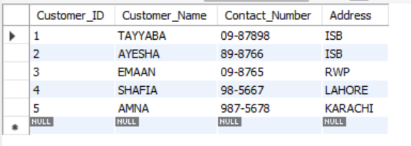

1. **Categories:**

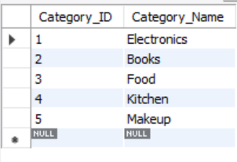

1. **Products:**

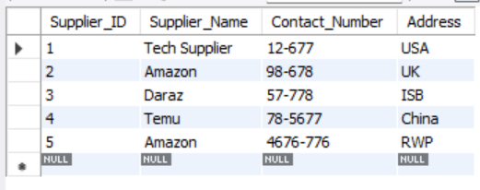

1. **Suppliers:**

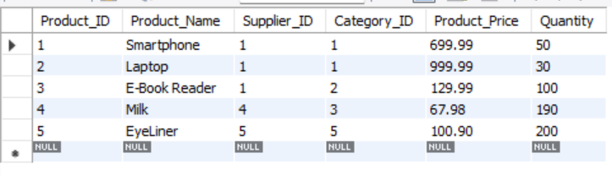

1. **Orders:**

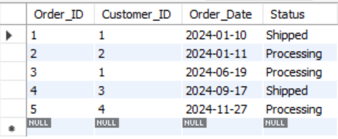

1. **OrderDetails:**

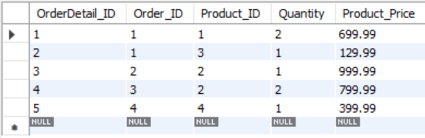

**TASKS:**

**TASK 1:**

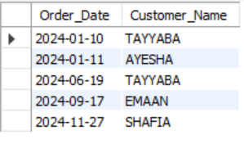

**TASK 2:**

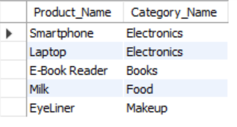

**TASK 3:**

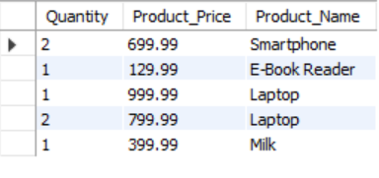

**TASK 4:**

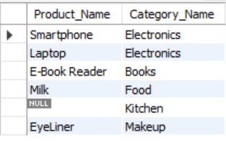

**TASK 5:**

